**Credit Card Approval Prediction:**

Not everyone can obtain a credit card with ease. The bank decides whether or not to issue a credit card based on multiple factors that demonstrate how trustworthy the person is. And credit scores objectively quantify this trust factor and amount of risk. So this project aims to create and compare different ML models that can find out if an applicant is ‘good’ or ‘bad’ client for obtaining a credit card and to pick the best model out of all these models and we try to boost the accuracy of the prediction as well.

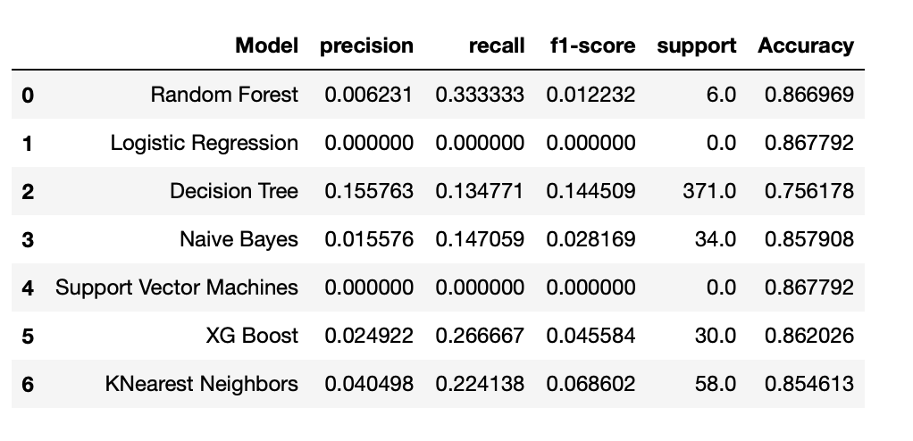

Prediction Approach Steps:

1. Importing Dataset.
2. Data Cleaning (Null Values & Outlier Detection & Treatment).
3. Feature Selection (Will use Correlation between features and target to get important features).
4. Splitting Features and labels.
5. Splitting entire dataset into training and testing datasets.
6. Model Building.
7. Model Performance Evaluation.
8. Applying boosting technique to boost the accuracy of the best model.

Models Used:

1. Random Forest
2. Logistic Regression
3. Decision Tree
4. Naive Bayes
5. Support Vector Machine
6. XG BOOST
7. KNearestNeighbors

Results:

User Manual:

Download the ipynb file and run it on your PC to see the entire approach implemented in python code for visualization I’m attaching a tableau link

<https://public.tableau.com/app/profile/jignesh.vanam/viz/AIFINALPROJECT_16525013174610/Dashboard1?publish=yes>